**Calculating Family Expenses using Service Now**

**Team Details:**

|  |
| --- |
| **TEAM ID:**  NM2025TMID13023 |

|  |  |
| --- | --- |
| Team Size | 4 |
| Team Leader | VISHAL KRISHNA M S |
| Team Member | VIGNESHWAR S |
| Team Member | VIJAYA RAGAVAN K |
| Team Member | YUVARAJ A |

**Project Description:**

The project aims to develop a comprehensive expense calculation system using ServiceNow. This system will enable users to track and manage family expenses efficiently. It will include features such as expense categorization, budget setting, real-time tracking, and reporting capabilities. Utilizing ServiceNow's robust platform, the project will ensure seamless integration, user-friendly interface, and scalability to accommodate varying family sizes and financial complexities. The end goal is to empower users with the tools they need to make informed financial decisions and promote financial well-being within the family unit.

**Objectives:**

1. **Develop a comprehensive expense tracking system using ServiceNow**.Build a custom application that enables users to record, categorize, and manage family expenses efficiently.
2. **Implement real-time budget monitoring and alerts**. Allow users to set budgets and receive notifications when spending approaches or exceeds limits.
3. **Design user-friendly interfaces for seamless interaction**. Create intuitive forms and dashboards that simplify data entry and financial review for all users.
4. **Generate detailed financial reports to support informed decision-making**. Provide visual summaries and analytics to help families understand spending patterns and improve financial planning.

**Skills Required :**

IOT Open Hardware platforms, Data Structures.

**TASK INITIATION:**

**Milestone 1: Setting Up ServiceNow Instance**

**Activity 1: Setting Up ServiceNow Instance**

1. Sign up for a developer account on the ServiceNow Developer site “https://developer.servicenow.com”.
2. Once logged in, navigate to the "Personal Developer Instance" section.
3. Click on "Request Instance" to create a new ServiceNow instance.
4. Fill out the required information and submit the request.
5. You'll receive an email with the instance details once it's ready.
6. Log in to your ServiceNow instance using the provided credentials.
7. Now you will navigate to the ServiceNow.

**Milestone 2: Creation Of New Update Set**

**Activity 1: Creation Of New Update Set**

1. Go to All >> In the filter search for Local Update set > click on New.  
   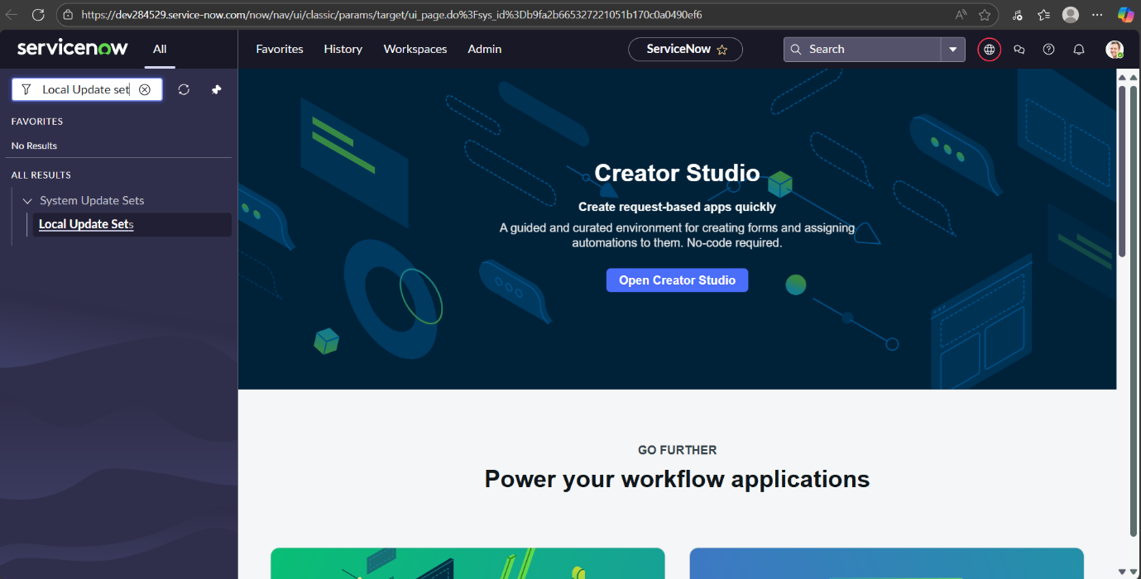
2. Enter the Details as:   
   Name : Family Expenses
3. Then click on Submit and Make current.  
   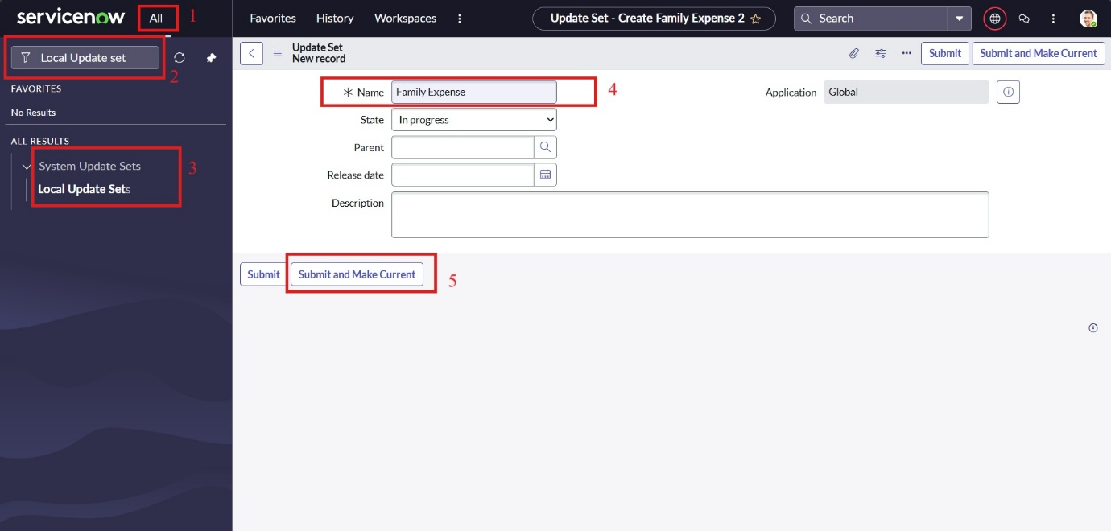

**Milestone 3: Creation Of Table**

**Activity 1: Creation Of Family Expenses Table**

1. Go to All > In the filter search for Tables > click on New.
2. Enter the Details:  
   Label : Family Expenses  
   Name : Auto-Populated  
   New menu name : Family Expenditure  
   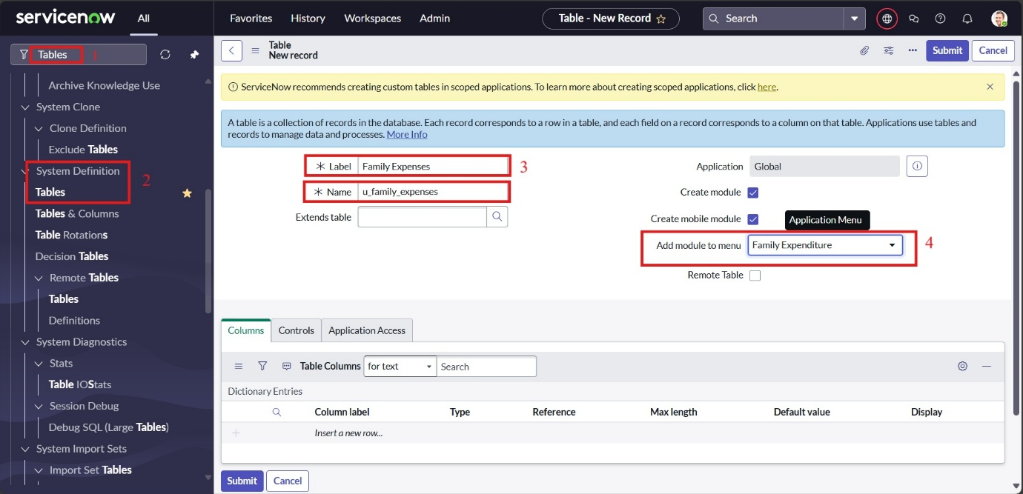
3. Go to the Header and right click there>> click on Save.

**Activity 2: Creation Of Columns (Fields)**

1. Near Columns Double click near insert a new row.
2. Give the details as:  
   Column label : Number  
   Type : String
3. Double click on insert a new row again
4. Give the details as:  
   Column label : Date  
   Type : Date
5. Double click on insert a new row again
6. Give the details as:  
   Column label : Amount  
   Type : Integer
7. Double click on insert a new row again
8. Give the details as:  
   Column label : Expense Details  
   Type : String  
   Max length : 800  
     
   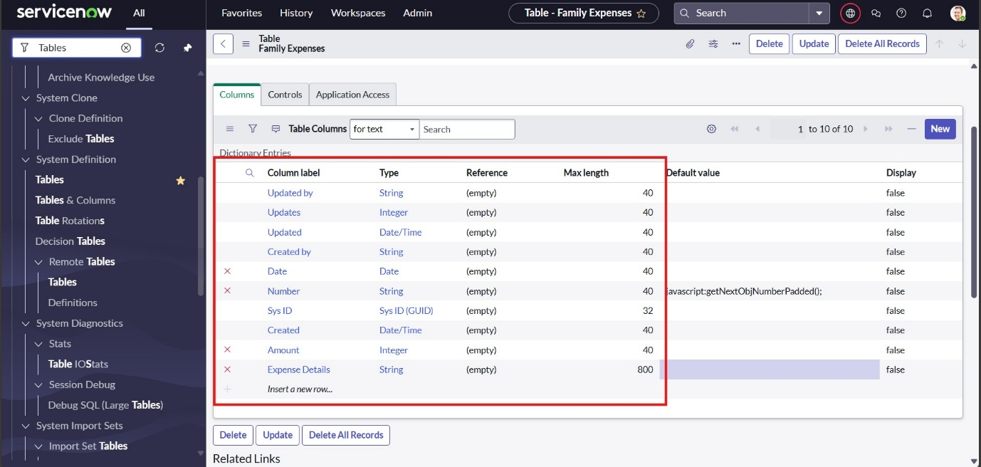
9. Go to the Header and right click there>> click on Save.

**Activity 3 : Making Number Field An Auto-Number**

1. Double click on the Number Field/Column.
2. Go down and double click on Advanced view
3. In Default Value:

Use dynamic default : check the box

Dynamic default value : Get Next Padded Number

1. Click on Update.  
   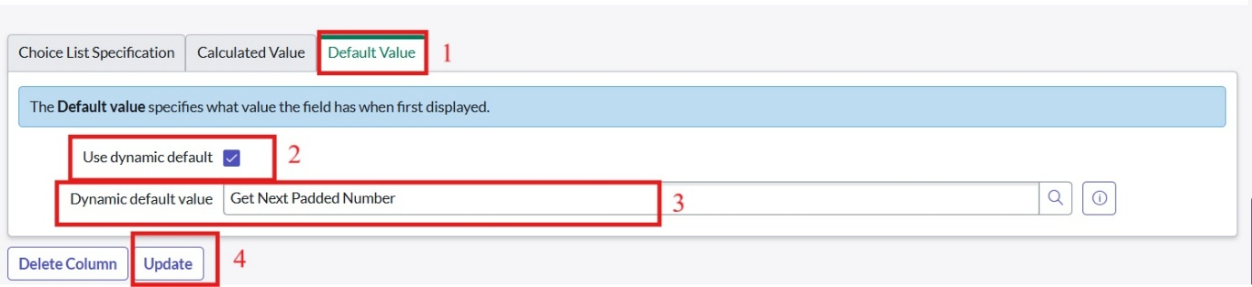
2. Go to All >> In the filter search for Number Maintenance >> select Number Maintenance
3. Click on New.
4. Enter the below Details:  
   Table : Family Expenses  
   Prefix : MFE  
   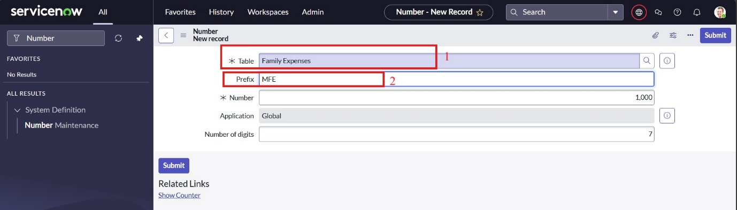
5. Click on Submit.

**Activity 4 : Configure The Form**

1. Go to All >> In the filter search for Family Expenses >> Open Family Expenses
2. Click on New
3. Go to the Header and right click there>> click on Configure >> Select Form Design
4. Customize or Drag Drop the form as per your requirement.  
   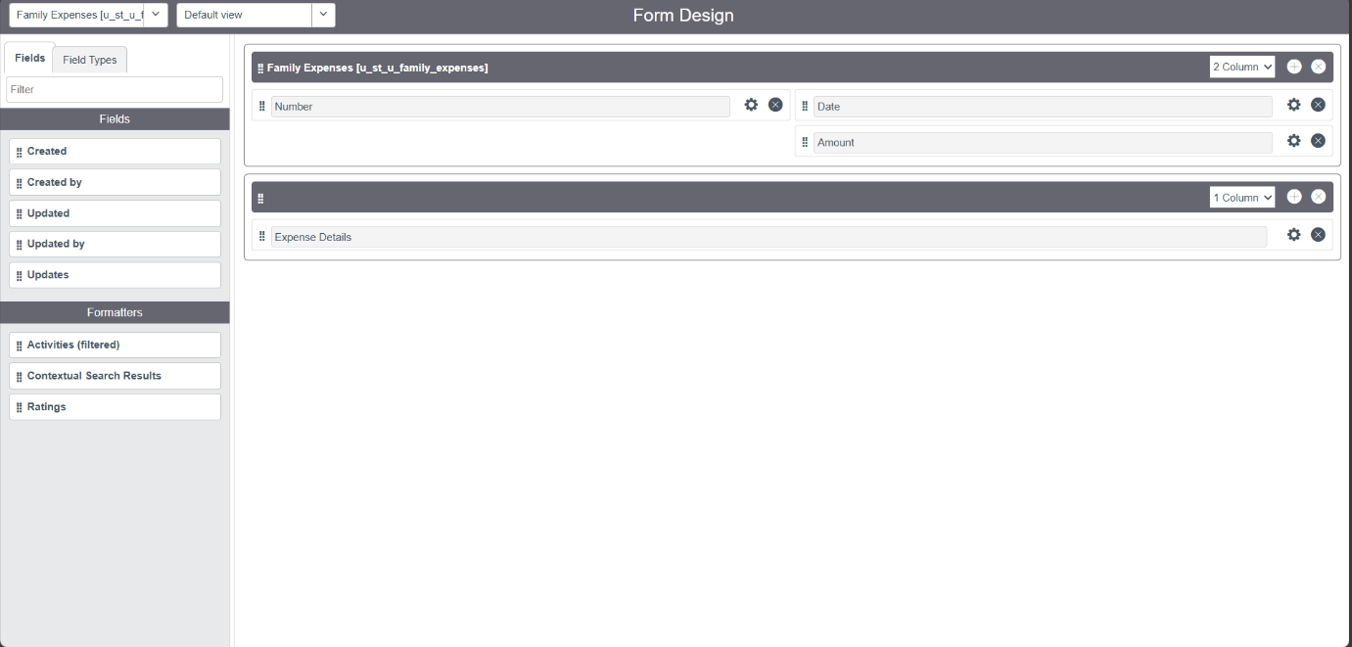
5. Make Number Read-Only Field by clicking on the gear icon and checking Read-Only
6. Make Date, Amount Mandatory Field by clicking on the gear icon and checking Mandatory
7. Click on Save.

**Milestone 4 : Creation Of Table (Daily Expenses)**

**Activity 1 : Creation Of Daily Expense Table**

1. Go to All > In the filter search for Tables > click on New.
2. Enter the Details:  
   Label : Daily Expenses  
   Name : Auto-Populated  
   Add Module to menu : Family Expenditure  
   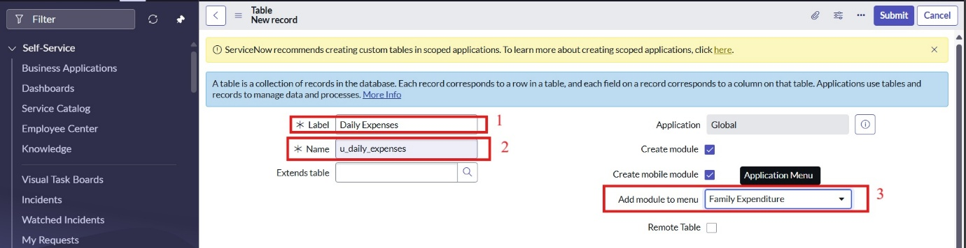
3. Go to the Header and right click there>> click on Save.

**Activity 2: Creation Of Columns**

1. Near Columns Double click near insert a new row.
2. Give the details as:  
   Column label : Number  
   Type : String
3. Double click on insert a new row again
4. Give the details as:  
   Column label : Date  
   Type : Date
5. Double click on insert a new row again
6. Give the details as:  
   Column label : Expense  
   Type : Integer
7. Double click on insert a new row again
8. Give the details as:  
   Column label : Family Member Name  
   Type : Reference  
   Reference : User (sys_user)  
   Max length : 800
9. Double click on insert a new row again
10. Give the details as:  
    Column label : Comments  
    Type : String  
    Max length : 800
11. Go to the Header and right click there>> click on Save.

**Activity 3: Making Number An Auto-Number**

1. Double click on the Number Field/Column.
2. Go down and double click on Advanced view
3. In Default Value:

Use dynamic default : check the box

Dynamic default value : Get Next Padded Number

1. Click on Update.  
   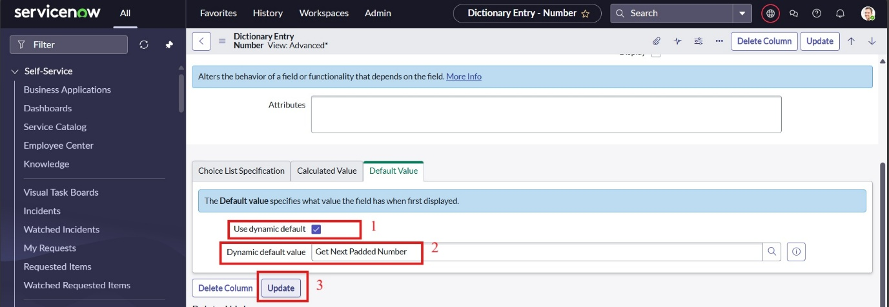
2. Go to All >> In the filter search for Number Maintenance >> select Number Maintenance
3. Click on New.
4. Enter the below Details:  
   Table : Family Expenses  
   Prefix : MFE  
   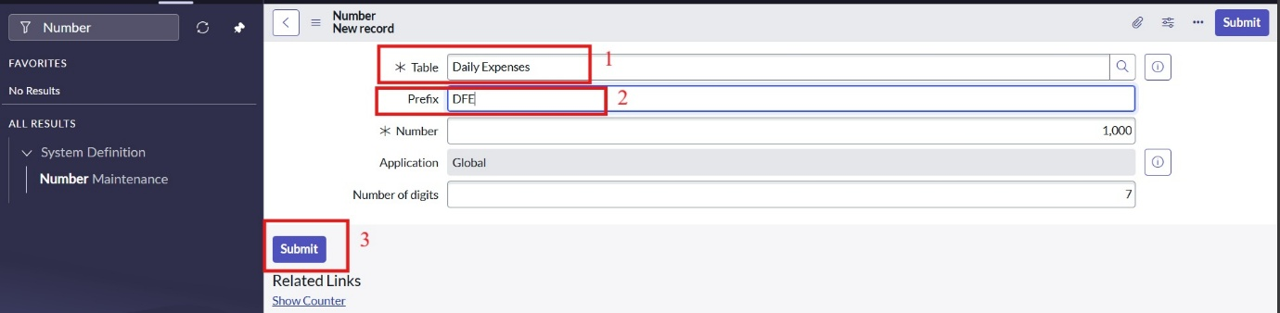
5. Click on Submit.

**Activity 4: Configure The Form**

1. Go to All >> In the filter search for Daily Expenses >> Open Daily Expenses
2. Click on New
3. Go to the Header and right click there>> click on Configure >> Select Form Design
4. Customize or Drag Drop the form as per your requirement.  
   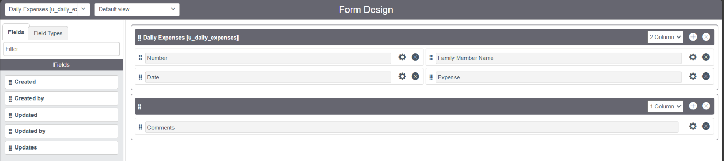
5. Make Number Read-Only Field by clicking on the gear icon and checking Read-Only
6. Make Date, Family Member Name Mandatory Field by clicking on the gear icon and checking Mandatory
7. Click on Save.

**Milestone 5: Creation Of Relationship**

**Activity 1: Creation OF Relationship Between Family Expenses Table and Daily Expenses Table**

1. Go to All >> In the filter search for Relationships >> Open Relationships
2. Click on New.
3. Enter the details:

Name : Daily Expenses

Applies to table : Select Family Expenses

Quries from table : Select Daily Expenses

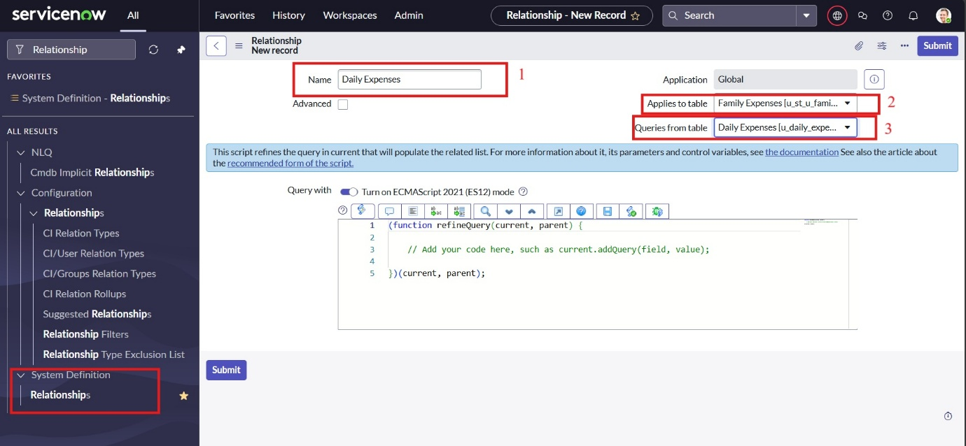

1. Click Save.

**Milestone 6: Configuring Related Lists On Family Expesnses**

**Activity 1: Configuring Related Lists On Family Expesnses**

1. Go to All >> In the filter search for Family Expenses >> Open Family Expenses
2. Click on New
3. Go to the Header and right click there>> click on Configure >> Select Related Lists
4. Add Daily Expenses to the Selected Area.
5. Click on Save.

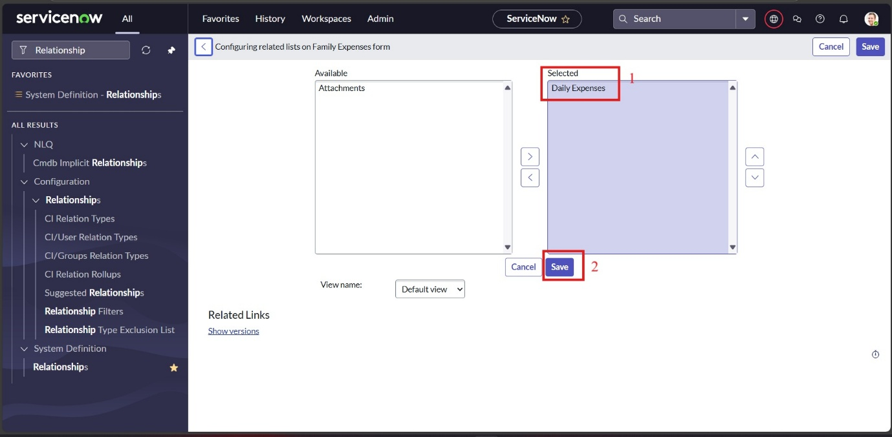

**Milestone 7: Creation Of Business Rule**

**Activity 1: Creation Of Business Rule**

1. Go to All >> In the filter search for Business Rules.
2. Under System Definition Select Business Rules then click on New.
3. Enter the Details:  
   Name : Family Expenses BR  
   Table : Select Daily Expenses  
   Check Advanced  
   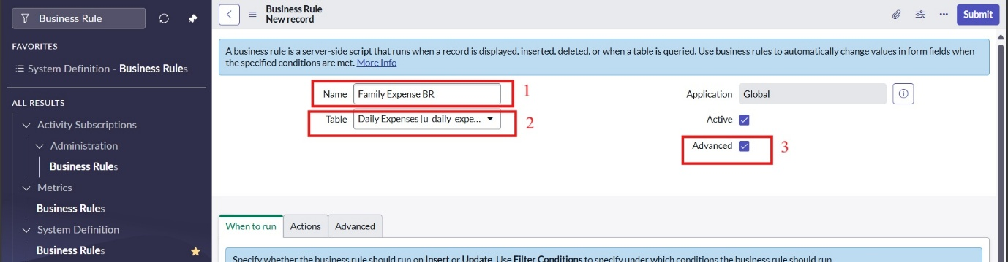
4. In when to run Check Insert and Update  
   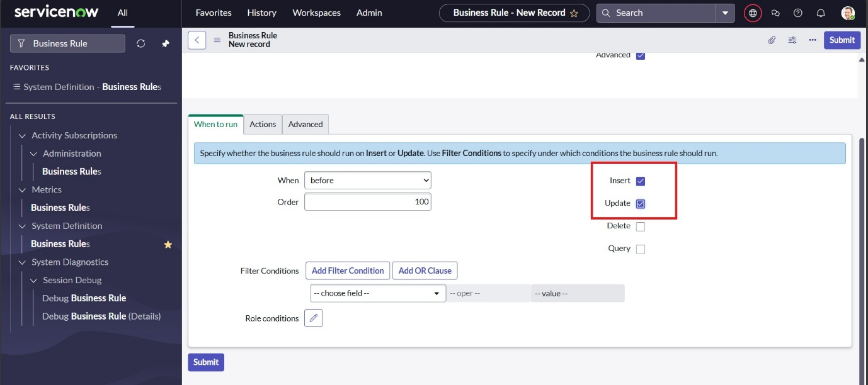
5. In Advance(we write the code): Write the below code >>  
     
   (function executeRule(current, previous /*null when async*/) {  
   var FamilyExpenses = new GlideRecord('u_st_u_family_expenses');  
   FamilyExpenses.addQuery('u_date',current.u_date);  
   FamilyExpenses.query();  
   if(FamilyExpenses.next())  
   {  
   FamilyExpenses.u_amount += current.u_expense;  
   FamilyExpenses.u_expense_details += ">"+current.u_comments+":"+"Rs."+current.u_expense+"/-";  
   FamilyExpenses.update();  
   }  
   else  
   {  
   var NewFamilyExpenses = new GlideRecord('u_st_u_family_expenses');  
   NewFamilyExpenses.u_date = current.u_date;  
   NewFamilyExpenses.u_amount = current.u_expense;  
   NewFamilyExpenses.u_expense_details += ">"+current.u_comments+":"+"Rs."+current.u_expense+"/-";  
   NewFamilyExpenses.insert();  
   }  
   })(current, previous);  
   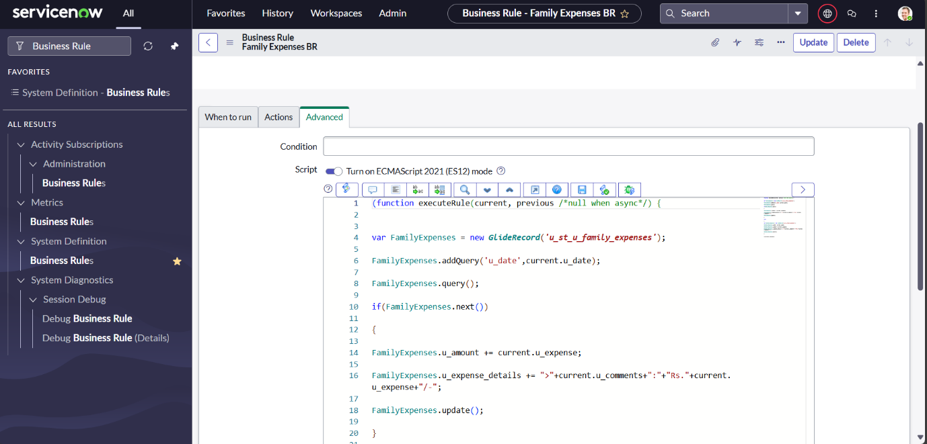
6. Go to the Header and right click there>> click on Save.

**Milestone 8: Configure The Relationship**

**Activity 1: Configure The Relationship**

1. Go to All >> In the filter search for Relationships >> Open Relationships.
2. In that, open Daily Expenses Relationship.
3. For Applies to table : Select Family Expenses.
4. In Query with : write the below Query.  
   (function refineQuery(current, parent) {  
   // Add your code here, such as current.addQuery(field, value);  
   current.addQuery('u_date',parent.u_date);  
   current.query();  
   })(current, parent;
5. Click on Update.  
   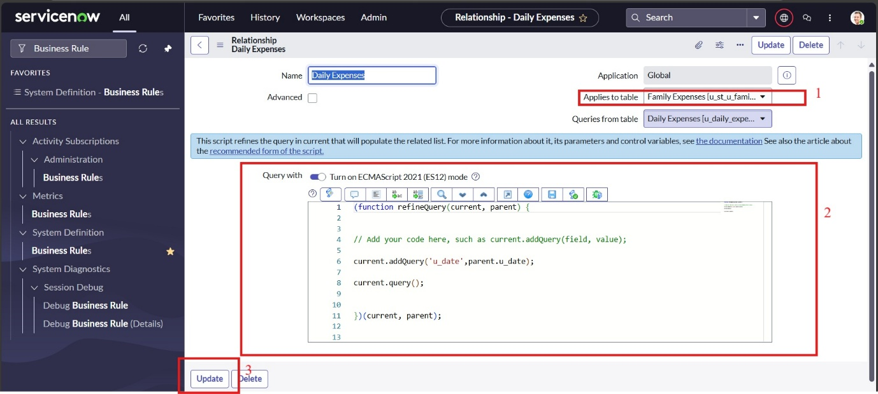

**Conclusion:**

This project demonstrates how ServiceNow can be effectively used to manage and track family expenses through a structured and user-friendly interface. By creating custom tables for **Family Expenses** and **Daily Expenses**, establishing relationships between them, and implementing business rules, I was able to automate data flow and improve accuracy in expense tracking.

The process of configuring forms, auto-numbering fields, and designing related lists helped me understand the practical applications of ServiceNow beyond theoretical learning. Debugging reference fields and scripting relationships also strengthened my problem-solving skills and gave me hands-on experience with real-world scenarios.

`